**AUTOMATED BIN MESSENGER**

***Submitted by***

**KEVIN FRASER E (REG.NO 2019102064)**

**LOGESH K (REG.NO 2019102066)**

**MOHITH D (REG.NO 2019102087)**

**KRISHNAKUMAR SS (REG.NO 2019102065)**

***for the Course***

**19UCS607–PRODUCT DEVELOPMENT PROJECT**

***In***

**B.E. COMPUTER SCIENCE AND ENGINEERING**

**SETHU INSTITUTE OF TECHNOLOGY, PULLOOR**

**An Autonomous Institution Affiliated to Anna University, Chennai**

**PULLOOR, KARIAPATTI – 626115**

**JUNE 2022**

**SETHU INSTITUTE OF TECHNOLOGY**

**An Autonomous Institution**

**BONAFIDE CERTIFICATE**

Certified that this project report **“AUTOMATED BIN MESSENGER”** is the bonafide work of **“KEVIN FRASER E, LOGESH K, MOHITH D,KRISHNAKUMAR SS”** who carried out the project work under my supervision.

|  |  |
| --- | --- |
| **SIGNATURE Dr.M.PARVATHY,**  **PROFESSOR & HEAD**  Department of computer Science  And Engineering.  Sethu Institute of Technology,Pulloor,Kariapatti,  Virudhunagar-626115 | **SIGNATURE**  **Dr.M.PUNITHA,**  **PROFESSOR & HEAD**  ASSOCIATIVE PROFESSOR  Department of computer Science  And Engineering.  Sethu Institute of Technology,Pulloor,Kariapatti,  Virudhunagar-626115 |

Submitted for the Project Viva – Voce held on

**INTERNAL EXAMINER EXTERNAL EXAMINER**

**ABSTRACT**

This project smart garbage dustbin system is a very smart system

which will help to keep our cities clean. This project can reduce their

time and effort in an efficient manner. Automation is that the most

demand able feature currently daily. For this purpose, smart dustbins

are a much suitable approach. It will be helpful to develop a green and

smart city. For this, we have to develop an automatic smart dustbin

which will first be able to detect the current status of the garbage bin

send the information to the garbage collection vehicle employee.

They can immediately take action to empty. It ultimate helps to

keeping cleanness in the society and hence the expansion of diseases

caused by waste material is reduced. This paper gives an inclusive

and detailed survey of waste management models. Entirely, this paper

suggests the topology of the waste management system which is the

smart procedure as key enabling expertise in existing waste

management system

This smart garbage dustbin is a very innovative system which will

help to keep the cities clean. This system monitors the garbage bins

and informs about the level of garbage collected in the garbage bins.

For this the system uses ultrasonic sensors placed over the bins to

detect the garbage level and compare it with the garbage bins depth.

The overflowing of the garbage bins is very common in many cities,

but this will impact our society and our surroundings. It will damage

the environment day by day to cause the many types of pollution

along with to create many diseases for human and other animals also.

We proposed smart dustbin system which will monitor and alert when

the garbage level crosses the threshold level of the garbage bin. This

process will be carried out with the help of sensors, ATMEGA16 and

ESP8266. Now days in most cities there are many dustbins which are

in bad conditions. The garbage in a dustbin are all overflowed of the

dustbin. Many people are throwing garbage on that dustbin which are

already full or overflowed. Due to this unclean of garbage bins

pollution is increases which are bad for the environment. This creates

a very bad look of the city which is a way to support to the air

pollution and to some harmful diseases which are easily spreadable.

|  |  |  |
| --- | --- | --- |
| S.NO | TITLE | PAGE.NO |
| 1 | INTRODUCTION | 6 |
| 2 | OBJECTIVE OF THE INNOVATIVE IDEAS | 7 |
| 3 | LITERATURE SURVEY | 8 |
| 4 | EXISTING SYSTEM | 14 |
| 5 | PROPOSED SYSTEM | 15 |
| 6 | PRODUCT DEVELOPMENT | 16 |
| 7 | VALUE PROPOSITION | 31 |
| 8 | MARKETING POTENTIAL | 31 |
| 9 | FINANCIAL ESTIMATION | 32 |
| 10 | CONCLUSION | 33 |
| 11 | REFERENCES | 34 |

**INTRODUCTION**

With increase in population, the scenario of cleanliness with respect to garbage management is degrading tremendously. The overflow of garbage in public areas creates the unhygienic conditions in the nearby surrounding. In our city we see the garbage bins or dustbins placed at places overflowing. It creates unhygienic conditions and may provoke several diseases to the surrounding people. Generally, we see that they have a regular schedule of picking up these garbage bins or dustbins. This schedule varies as per the population of that place. It can be once in a day or twice in a day or in some cases once in two days. However we see that in case there is some festival or some function, lots of garbage material is generated by people in a particular area. To avoid all such situations, we are going to implement this project.

**OBJECTIVE OF INNOVATIVE IDEAS**

Nowadays, Waste management is one amongst the first issues that the

globe faces no matter the case of a developed or developing country.

The key issue in waste management is that the rubbish bin at public

places gets overflowed well before the commencement of the

consecutive cleansing method. Atmosphere pollution could be a

serious part of recent advancements. Majority of viruses and

microorganism infections develop within the impure atmosphere.

Safeguarding the atmosphere victimization technology sources is

required nowadays. Majority of the general public atmosphere like

restaurants appears to be impure with the material. So, modernization

of the cleansing victimization physics and communication is required

by transmission the good technology. IOT based mostly Embedded

system is that the technology during which Associate in Nursing

embedded developer connects multiple embedded devices to the web.

IOT for embedded systems incorporates several things like grouping

and analyzing an oversized quantity of knowledge} from totally

different views and summarizing them into helpful information to

enhance the method services and devices square measure used

nowadays and creating the embedded devices smarter than before.

Good embedded systems want to design and style components to suit

time period operations. With billions of devices expected to affix

within the coming back years, analysts expect that IOT can have a big

impact on device style.

**LITERATURE SURVEY**

1. **IoT Based Smart Trash Bins – A Step Toward Smart City (December 2017) Chaitanya Jambotkar, Shamlee Rashinkar, Sneha Ghatole, Swati Kadapatti, Varsha Yadave**

The main plan of planned work is to develop a wise intelligent

garbage alert system for correct garbage management. A smart

alert system is meant for garbage clearance by giving an associate

alert signal to the municipal internet server for immediate cleanup

of ashcan with correct verification supported level of garbage

filling. This method is assisted by the inaudible device that is

interfaced with Arduino UNO to envision the amount of garbage

crammed within the garbage bin and sends the alert to the

municipal internet server once if garbage is ninetieth crammed via

IoT.Once the alert is received, Municipal Corporation takes

initiative to scrub identical. After cleanup the rubbish bin,

municipal internet server gets updated regarding the rubbish bin

been cleansed. This system provides information regarding the

status of how a waste collection is being © 2019 IJSRET 143 done

and followed up by the municipality authority. The technologies

used at disposal to develop this sensible system have conjointly

evolved, i.e. from WSNs to RFIDs to now the most popular

Internet of Things (IoT). At the hardware level, the sensor system

may be a garbage bin with an inaudible device, a micro-controller .

1. **IOT Based Smart Garbage Monitoring and Alert System Using Arduino UNO (February 2018) K.Harika, Muneerunnisa, V.Rajasekhar,P.Venkateswara Rao, L.J.N Sree Lakshmi**

This paper describes the most theme of the work is to develop a

wise alert system for garbage clearance by giving AN alert

signal to the municipal net server for fast cleanup of dirt bin

with correct verification supported level of garbage filling. This

method is motor-assisted by the inaudible sensing element that is interfaced with Arduino UNO to see the extent of garbage stuffed within the dirt bin and sends the aware of the municipal net server once if garbage is stuffed. the entire method is upheld by AN embedded module integrated by exploitation GSM and GPS with IOT facilitation. the $64000 time standing of however waste assortment is being done might be monitored and followed up by the municipality authority with the help of this technique. Additionally, to the present the mandatory remedial measures might be tailored. A humanoid application is developed and connected to an online server to intimate the alert kind the microcontroller to the urban workplace and to perform the remote observance of the cleanup method, done by the staff, thereby reducing the manual method of observance and verification. The notifications area unit sent to the humanoid application exploitation Wi-Fi module. Arduino UNO is the main Module during this project. The inaudible sensing element that is interfaced with Arduino UNO to see the extent of garbage stuffed within the trash bin. GSM/GPRS Module is employed to ascertain communication between a user pc and a GSM-GPRS system and exploitation this module we have a tendency to get the SMS notification from the trashcan.GPS Module may be a navigation device it'll indicate the situation wherever garbage is stuffed and by exploitation Wi-Fi Module we have a tendency to get distinctive IPaddress for SMS and conjointly Municipal Officer will see the rubbish bin standing in “All things talk” computing machine.

**3. Eco - friendly Environment with RFID Communication Imparted Waste Collecting Robot (July 2015) K. Vidyasagar, M. Sumalatha,K. Swathi,M. Rambabu**

This paper mentioned that restaurant to keep the premises clean and

green. Smart waste collecting system enabled to develop a

methodology to collect the waste material into the dustbin provided at

the guided robot. An RFID (Radio-frequency identification)

communication is adapted to communicate the table occupier with the

mobile robot. An RFID tag is provided to each table and an RFID

reader is equipped with the guided robot. The command signal

outputted by the table occupier will be transmitted to the central

control room using an RF transmitter. RF receiver at the control room

will receive the signal and fed as input to the microcontroller ARM7.

The microcontroller will output the necessary commands to the robot

to collect the waste material from the particular table. To drive the

robot to the required table, a path finding mechanism has been

adopted using optimum path algorithm. An IR sensor assembly is

equipped with the robot to follow the specified optimum path. The

status of the task is communicated to the control room by imparting

the IEEE 802.15.4 communication device. The experimental results

encouraged to implement the developed mechanism for real-time

applications.

1. **Smart Garbage Management System Using Internet of Things (IOT) For Urban Areas (May 2018) Ms. Nisha Bhagchandani, Ms. Rupa, Ms. Rajni Kumari, Mr. Ashish Mathur**

This project manages the garbage collection done by Municipal

Corporation with the help of an IOT based embedded device

attached to the dustbin of each area, this device continuously

update the standing of dustbins in every space to the web site designed for this management. This device ceaselessly detects the amount of ash-bin mistreatment supersonic detector and because the ash-bin gets full it'll update its standing of obtaining full on the web site designed for garbage management along with date and time and will go to waiting for state and remain in this state till dustbin gets empty. A timer is also set simultaneously in this state for a fixed duration within which dustbin must be cleaned by the Municipal Corporation. If this timer gets expired and dustbin is not cleaned by their employees on given time then the device will be sent a message to the higher authority that dustbin not cleaned on time and again set the timer for the same duration and remain in waiting for the state. Once the dustbin is cleaned by the employees the device will come out of waiting for state and will update its status of getting cleaned on the website along with date and time. Thus a record is maintained regarding dustbin status for each area in the website in tabular form using IoT technology along with the embedded system which will efficiently manage the assortment garbage pickup trash collection trash pickup by the Municipal Corporation and can resolve the foremost settings issue of inefficient garbage collection ends up in a clean and healthy environment.

1. **Smart Bin: Internet-of-Things Garbage Monitoring System (2017) Ku Azir K.N.F, Mustafa M.R**

This paper describes the ARM microcontroller which controls

system operation whereas everything will be connected to Thing Speak. This work demonstrates a system that enables the waste management to watch supported the amount of the rubbish depth within the garbage can. The system shows the standing of various four styles of garbage; domestic waste, paper, glass, and plastic through LCD and Thing Speak in a real-time to store the data for future use and analysis, such as prediction of the peak level of garbage bin fullness. It is expected that this method will produce a greener atmosphere by observation and dominate the gathering of garbage neatly through Internet-of-Things. Waste is often divided into 2 classes, liquid or solid waste both can be hazardous. Both of this waste can be group into organic, reusable and recyclable waste. This project has 2 half that are transmitter section and receiver. The 8051microcontroller, RF Transmitter and sensors in the transmitter section that attached to the dustbin. The receiver section victimization RF Receiver, Intel Galileo, and Web Browser is used. This system can detect waste level in the dustbin and avoid the overflow of a dustbin. Smart Garbage System (SGS) is proposed to reduce the amount of food waste. The system exchange data with one another victimization wireless mesh networks and a router and server collect and analyze the information for service provisioning and been operated as a pilot project in Gangnam district. The results showed that the common quantity of waste material may be reduced by thirty third. “Smart Bin’ was designed to manage the waste collection system based on the smart city.

1. **Smart Bin Implementation for Smart Cities (September-2015) Narayan Sharma, Nirman Singha, Tanmoy Dutta**

This paper describes the appliance of our model of “Smart Bin” in managing the waste assortment system of a whole town. The network of sensors enabled sensible bins connected through the cellular network generates an out sized quantity of information, that is any analyzed and envisioned at real time to realize insights regarding the standing of waste round the town. This paper also aims at encouraging further research on the topic of waste management. The project offers U.S. one amongst the foremost economical ways that to stay our surroundings clean and inexperienced. The smart-bin designed are going to be causation knowledge regarding the degree of garbage collected in numerous elements of the city/town. The dataset created can be analyzed to gain lots of insights. The collected knowledge set over a amount of your time can produce a historical knowledge set. The dataset contains totally different variables of that "ID", is the unique ID of a bin, and is the primary key. Our smart-bin sends U.S. the message that contains the updated level of garbage alongside the Date and Timestamp. The other factors like Location of the smart-bin and Full or not the status is included using SQL joints and Excel spreadsheet functions. The main aim of our smart bins knowledge analysis is to form a prediction model which might predict the time a selected smart-bin are going to be obtaining stuffed up.

**EXISTING SYSTEM**

* There needs to be a system that gives prior information of the filling of the bin that alerts the municipality
* So that they can clean the bin on time and safeguard the environment.
* To avoid all such situations we intend to propose a solution for this problem "Smart Bin",
* Which will alarm and inform the authorized person when the bin is about to be filled.
* Then a message will be sent to the authorized person to collect the garbage from the particular area
* System requires more number of waste bins for separate waste collection as per population in the city. This results into high initial cost due to expensive smart dustbins compare to other methods.

**PROPOSED SYSTEM**

* In this work, we present an automated bin messenger alerts the concerned authority via the GSM. "Smart Bin", which will alarm and inform the authorized person when the bin is about to be filled. Then a message will be sent to the authorized person to collect the garbage from the particular area.
* A project has been developed to control the overfilling of the dustbin by making the dustbin smart enough to notify itself for its cleaning.
* In this project the smart dustbin management system is built on the microcontroller based system having ultrasonic sensors on each of the four dustbins that will show the current status of garbage on the LCD screen as well as on the mobile.

➨It decreases traffic flow and consecutively noise due to less air pollution as result of less waste collection vehicles on the roads. This has become possible due to two way communication between smart dustbins and service operators.

➨It keeps our surroundings clean and green and free from bad odour of wastes, emphasizes on healthy environment and keep cities more beautiful  
➨It further reduces manpower requirements to handle the garbage collection process

**PRODUCT DEVELOPMENT**

**Software Specification**

The software requirements document is the specification of the system. It should include both a definition and a specification of requirements. It is a set of what the system should do rather than how it should do it. The software requirements provide a basis for creating the software requirements specification. It is useful in estimating cost, planning team activities, performing tasks and tracking the teams and tracking the team’s progress throughout the development activity.

**Software Requirements:**

* OS - Windows 7 32bit

**Hardware Specification**

The hardware requirements may serve as the basis for a contract for the implementation of the system and should therefore be a complete and consistent specification of the whole system. They are used by software engineers as the starting point for the system design.

**Hardware Requirements**:

* **ARDUINO BOARD**
* **GSM BOARD**
* **ULTRA SONIC SENSOR**
* **JUMPER CABLE**
* **SIM**
* **IR SENSOR**

**BLOCK DIAGRAM**

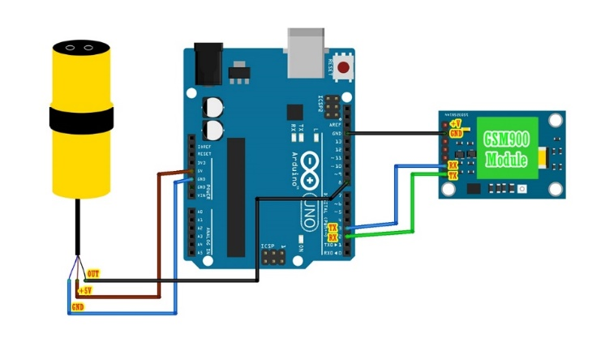

**Components Details**

1. ARDUINO BOARD
2. GSM BOARD
3. ULTRA SONIC SENSOR
4. JUMPER CABLE
5. SIM
6. IR SENSOR

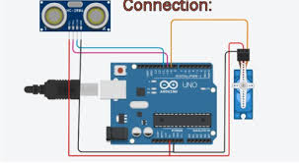

**Components Description**

**Arduino**

**Arduino is an open source electronics creation platform**, which is based on free, flexible and easy to use hardware and software for creators and developers. This platform allows you to create different types of single-board microcomputers to which the community of creators can give different types of use.

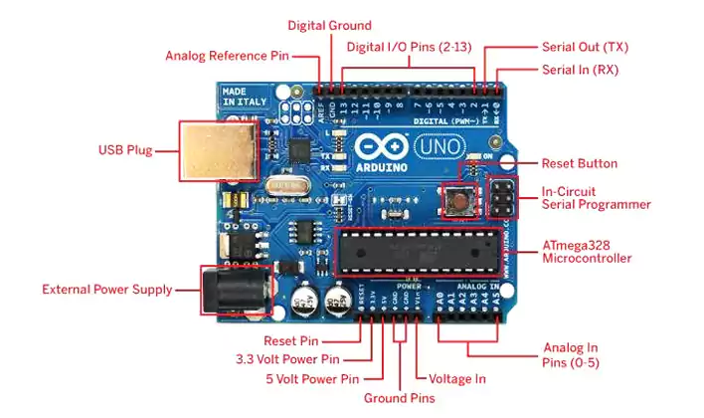

In order to understand this concept, first you need to know about free hardware and free software concepts. Free hardware is devices whose specifications and diagrams are publicly accessible, so anyone can replicate them. This means that Arduino offers the base **so that any other person or company can create their own boards**, being able to be different from each other but equally functional when starting from the same base.

Free software is a computer program **whose code is accessible by anyone** so that whoever wants to use can use and modify it. Arduino offers the Arduino IDE (Integrated Development Environment) platform, which is a programming environment with which anyone can create applications for Arduino boards, so that they can be given all kinds of utilities.

**How Arduino Works:**

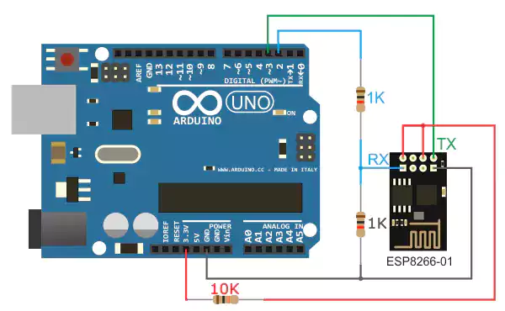

The Arduino is a board based on an ATMEL AVR microcontroller. Microcontrollers are **integrated circuits where instructions can be recorded**, which you write with the programming language that you can use in the Arduino IDE environment. These instructions allow you to create programs that interact with the circuitry on the board.

The most used microcontrollers on Arduino platforms are the [Atmega168](http://www.atmel.com/devices/atmega168.aspx), [Atmega328,](http://www.atmel.com/devices/atmega328.aspx) [Atmega1280](http://www.atmel.com/devices/atmega2560.aspx), [ATmega8](http://www.atmel.com/devices/ATMEGA8.aspx) for their simplicity, but it is being expanded to Atmel microcontrollers with 32-bit ARM architecture and also to Intel microcontrollers.

The Arduino microcontroller has communication ports and input / output ports. with which we can connect different types of peripherals on the board. The information of these peripherals that you connect will be transferred to the microcontroller, which will be in charge of processing the data that comes through them.

On the other hand, Arduino provides us with software consisting of a development environment [(IDE)](https://en.wikipedia.org/wiki/Integrated_development_environment) that implements the Arduino programming language, the tools to transfer the firmware to the microcontroller and the boot loader executed on the board. The main feature of the software and the programming language is its simplicity and ease of use.

**ULTRASONIC SENSOR**

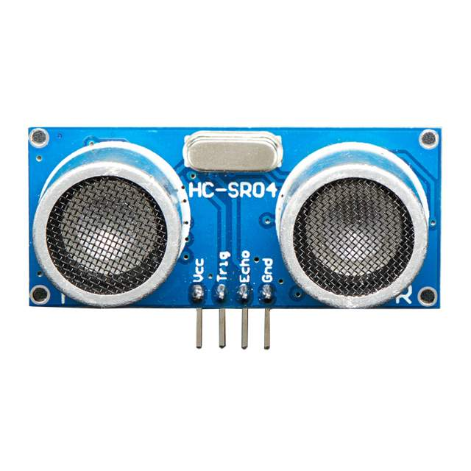

The ultrasonic sensor (or transducer) works on the same principles as

a radar system. An ultrasonic sensor can convert electrical energy into

acoustic waves and vice versa. The acoustic wave signal is an

ultrasonic wave traveling at a frequency above 18kHz. The famous

HC SR04 ultrasonic sensor generates ultrasonic waves at 40kHz frequency

Typically, a microcontroller is used for communication with an

ultrasonic sensor. To begin measuring the distance, the

microcontroller sends a trigger signal to the ultrasonic sensor. The

duty cycle of this trigger signal is 10µS for the HC-SR04 ultrasonic

sensor. When triggered, the ultrasonic sensor generates eight acoustic

(ultrasonic) wave bursts and initiates a time counter. As soon as the

reflected (echo) signal is received, the timer stops. The output of the

ultrasonic sensor is a high pulse with the same duration as the time

difference between transmitted ultrasonic bursts and the received echo signal.

**IR SENSOR**

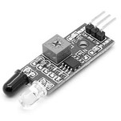

An infrared (IR) sensor is an electronic device that measures and

detects infrared radiation in its surrounding environment. Infrared

radiation was accidentally discovered by an astronomer named

William Herchel in 1800. While measuring the temperature of each

color of light (separated by a prism), he noticed that the temperature

just beyond the red light was highest. IR is invisible to the human eye,

as its wavelength is longer than that of visible light (though it is still

on the same electromagnetic spectrum). Anything that emits heat

(everything that has a temperature [above around five degrees Kelvin](https://www.livescience.com/50260-infrared-radiation.html))

gives off infrared radiation.

There are two types of infrared sensors: active and passive. Active

infrared sensors both emit and detect infrared radiation. Active IR

sensors have two parts: a light emitting diode (LED) and a receiver.

When an object comes close to the sensor, the infrared light from the

LED reflects off of the object and is detected by the receiver. Active

IR sensors act as [proximity sensors](https://www.fierceelectronics.com/sensors/what-a-proximity-sensor), and they are commonly used in

obstacle detection systems (such as in robots).

**Power Supply Adapter**

A power supply is an electronic circuit designed to provide various ac and dc voltages for equipment operation.

Proper operation of electronic equipment requires a number of source voltages. Low dc voltages are needed to operate ICs and transistors. High voltages are needed to operate CRTs and other devices. [**Batteries**](https://electricalacademia.com/batteries/lead-acid-battery-construction-working-charging/) can provide all of these voltages.

However, electricity for electrical and electronic devices are commonly supplied by the local power company. This power comes out of an outlet at 115-volt ac, with a frequency of 60 Hertz.

Different voltages are needed to operate some equipment.

## ****Power Supply Functions:****

The complete power supply circuit can perform these functions:

1. Step voltages up or step voltages down, by transformer action, to the required ac line voltage.
2. Provide some method of voltage division to meet equipment needs.
3. Change ac voltage to pulsating dc voltage by either half-wave or full-wave rectification.
4. Regulate power supply output in proportion to the applied load.

 Input is 117 volts ac. Processes used in a typical power supply are shown below the blocks. The output of the power supply can be dc or ac. The output of this supply is five volts dc.

**Jumper Cables**

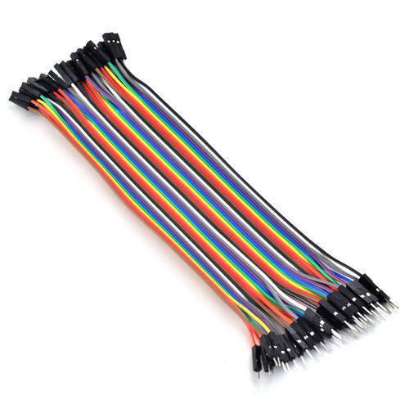

1. each of a pair of thick electric cables fitted with clips at either end, used for starting a vehicle by connecting its dead battery to the battery of another vehicle; a jump lead.

**ARDUINO IDE**

ARDUINO is an open-source prototyping platform based on easy-to-use hardware and software. The ARDUINO Integrated Development Environment - or ARDUINO Software (IDE) - contains a text editor for writing code, a message area, a text console, a toolbar with buttons for common functions and a series of menus. It connects to the ARDUINO and GENUINO hardware to upload programs and communicate with them.

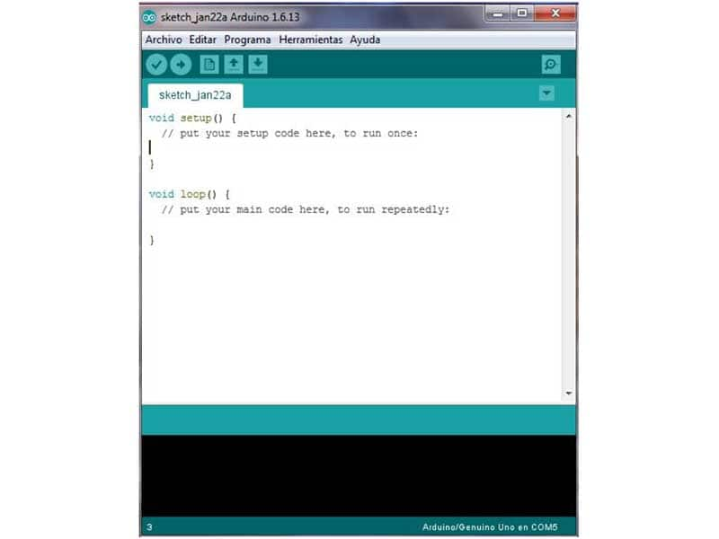

**The key features are:**

* Arduino boards are able to read analog or digital input signals from different sensors and turn it into an output such as activating a motor, turning LED on/off, connect to the cloud and many other actions.
* You can control your board functions by sending a set of instructions to the microcontroller on the board via Arduino IDE (referred to as uploading software).
* Unlike most previous programmable circuit boards, Arduino does not need an extra piece of hardware (called a programmer) in order to load a new code onto the board. You can simply use a USB cable.
* Additionally, the Arduino IDE uses a simplified version of C++, making it easier to learn to program.
* Finally, Arduino provides a standard form factor that breaks the functions of the microcontroller into a more accessible package.

### Download the IDE

First, you must download the IDE and install it. Start by visiting Arduino’s software page. The IDE is available for most common operating systems, including Windows, Mac OS X, and Linux, so be sure to download the correct version for your OS. If you are using Windows 7 or older, do not download the Windows app version, as this requires Windows 8.1 or Windows 10.

Once the installer has downloaded, go ahead and install the IDE. Chances are you will want to enable all options on the installer, including any USB drivers and libraries, but do make sure to read the EULA.

**The Arduino IDE**

The Arduino IDE is incredibly minimalistic, yet it provides a near-complete environment for most Arduino-based projects. The top menu bar has the standard options, including “File” (new, load save, etc.), “Edit” (font, copy, paste, etc.), “Sketch” (for compiling and programming), “Tools” (useful options for testing projects), and “Help”. The middle section of the IDE is a simple text editor that where you can enter the program code. The bottom section of the IDE is dedicated to an output window that is used to see the status of the compilation, how much memory has been used, any errors that were found in the program, and various other useful messages.

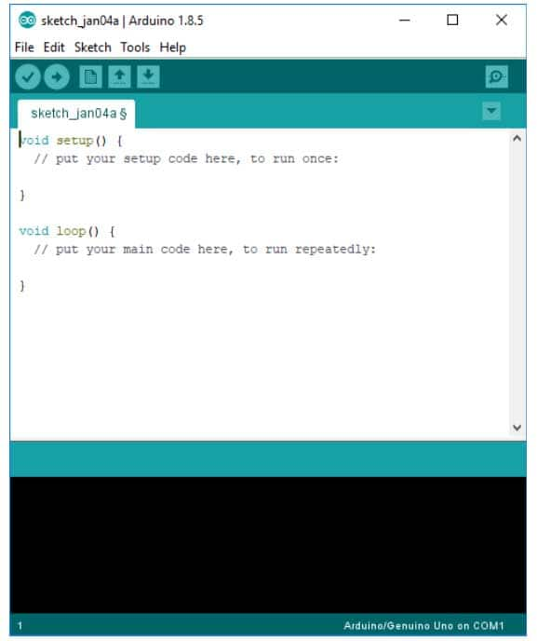

**The 6 Buttons**

While more advanced projects will take advantage of the built-in tools in the IDE, most projects will rely on the six buttons found below the menu bar.

Image of The button bar

*The button bar*

1. The **check mark** is used to verify your code. Click this once you have written your code.
2. The **arrow** uploads your code to the Arduino to run.
3. The **dotted paper** will create a new file.
4. The **upward arrow** is used to open an existing Arduino project.
5. The **downward arrow** is used to save the current file.
6. The far right button is a **serial monitor**, which is useful for sending data from the Arduino to the PC for debugging purposes.

**VALUE PROPOSITION**

* If You Are dealing directly with customers without any interference of any mediocre is called direct selling.
* In modern direct selling, the sales are made through one on one demonstration, personal contact agreement or internet sales.
* Examples are,
* Online Selling
* Own Brand Outlet

**MARKETING POTENTIAL**

The global waste management market size was valued at $1,612.0

billion in 2020, and is expected to reach $2,483.0 billion by 2030,

registering a CAGR of 3.4% from 2021 to 2030. Waste

management is the collection, transportation and disposable of

garbage, sewage, and other waste products. It involves treating

solid waste and disposing unwanted products and substances in a

safe and efficient manner. Waste management includes all types of

waste including solid, liquid, or gas. Waste management deals with

municipal, industrial, and hazardous waste.

**FINANCIAL ESTIMATION**

**Cost of Components**

1. Arduino Board –Rs.900
2. Dustbin– Rs.240
3. Power Supply Adapter– Rs.251
4. Jumper cables – Rs. 236
5. Ultrasonic sensor-Rs.400
6. Gsm Module- Rs.1,200

**CONCLUSION**

* In this work, we present an automated bin messenger alerts the concerned authority via the GSM.
* Where it provides the values which determine the amount of trash filled.
* This information is communicated to the caretakers using GSM technology
* With the advent of technologies, all the things around us are getting smarter. The above-depicted model of smart trash is cost effective and can be implemented in malls, airports, hospitals, schools, and colleges. which reduces the burden of people

**REFERENCES**

* [1] Narayan Sharma, NirmanSingha, Tanmoy Dutta (2015)“Smart

Bin Implementation for Smart Cities”, International Journal of

Scientific & Engineering Research, vol 6, Issue 9, pp-787-789.

* [2] K. Vidyasagar, M. Sumalatha, K. Swathi and M. Rambabu (2015),

“Eco-friendly Environment with RFID Communication Imparted

Waste Collecting Robot”, Journal of Academia and Industrial

Research (JAIR)Volume4,Issue2,pp.43-47.0

* [3]TwinkleSinha,MukeshKumar, P.Saisharan(2015), “SmartDustbin”, Inter

national Journal of Industrial Electronics and Electrical Engineering,

SRM University, India,vol-3, Issue-5, pp.101-104.

* [4] M.T.H. Shubho, M.T Hassan, M.R. Hossain, and M. N. Neema

(2013), “Quantitative Analysis of Spatial Pattern of Dustbins and its

Pollution in Dhaka City˗˗A GIS-Based Approach”, Asian Transactions

on Engineering (ATE ISSN: 2221-4267) vol. 03 Issue 04, pp.1-7

* [5] Narayan Sharma, NirmanSingha, Tanmoy Dutta (2015), “Smart

Bin Implementation for Smart Cities”, International Journal of

Scientific & Engineering Research, Volume 6, Issue 9, pp.787-791

.

* [6] Insung Hong, Sunghoi Park, Beomseok Lee, Jaekeun Lee,

Daebeom Jeong, and Sehyun Park (2014)., “IoT-Based Smart Garbage

System for Efficient Food Waste Management”, The Scientific World

Journal,Volume 2014.

* [7] Prof. R.M.Sahu, AkshayGodase, Pramod Shinde, ReshmaShinde

(2016), “Garbage and Street Light Monitoring System Using Internet

of Things”, International journal of innovative research in

electrical, electronics, instrumentation and control engineering Vol. 4,

Issue 4.

* [8] Vikrant Bhor1, Pankaj Morajkar2, Maheshwar Gurav3, Dishant Pandya

(2015), ”Smart Garbage Management System”, International Journal

of Engineering Research & Technology, Mumbai, India, vol. 4

Issue03, pp.1117-1119.

* [9] Neha Shinde, SayliBambre, Shradha Thakur, VarshaDevkule (2018),

“A Survey On Garbage Collection And Monitoring System For Smart

Cities Using IoT”, International Research Journal Of Engineering And

Technology, Volume 5, Issue 2.

* [10] "ZigBee Specification FAQ"*. Zigbee Alliance. Archived from the*

*original on 27 June 2013*. Retrieved 14 June 2013*.*